190905104
Lab 3

1)
// Block parent till child completes process using wait

#include <stdlib.h>
#include <unistd.h>
#include <stdio.h>
#include <sys/types.h>
#include <sys/wait.h>

int main(){
pid_t pid;
int status = 0;

pid = fork();

if(pid == -1){
printf("Error in forking\n");
exit(1);
}
else if(pid == 0){
printf("In the child process\n");
printf("Completing child process\n");
}
else{
printf("In the parent process.\nWaiting for child process to get over.\n");
wait(&status);
printf("Child process returned: %d\n", status);
printf("Completing parent process.\n");
}
return 0;
}

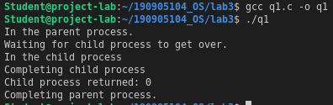

2)

// Load the binary of the previous program in child and use exec()

#include <stdlib.h>
#include <unistd.h>
#include <stdio.h>
#include <sys/types.h>
#include <sys/wait.h>

int main(){
pid_t pid;
int status = 0;

pid = fork();

if(pid == -1){
printf("Error in forking\n");
exit(1);
}
else if(pid == 0){
execlp("./q1", "q1", NULL);
}
else{
printf("Creating child.\n");
wait(&status);
}
return 0;
}

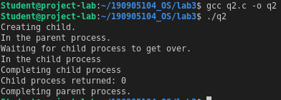

3)

// Write a program to create a child process. Display the process IDs of the process, parent and child (if any) in both the parent and child processes.

#include <stdlib.h>
#include <unistd.h>
#include <stdio.h>
#include <sys/types.h>
#include <sys/wait.h>

int main(){
pid_t pid;
int status = 0;

pid = fork();

if(pid == -1){
printf("Error in forking\n");
exit(1);
}
else if(pid == 0){
printf("In the child process\n");
printf("PID: %d\n", getpid());
printf("Parent PID: %d\n", getppid());
}
else{
printf("In the parent process\n");
printf("PID: %d\n", getpid());
printf("Parent PID: %d\n", getppid());
}
return 0;
}

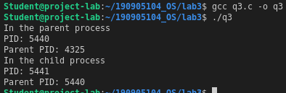

4)

/* Create a zombie (defunct) child process (a child with exit() call, but no corresponding wait() in the sleeping parent)
and allow the init process to adopt it (after parent terminates).
Run the process as a background process and run the “ps” command.*/
#include <stdlib.h>
#include <unistd.h>
#include <stdio.h>
#include <sys/types.h>
#include <sys/wait.h>

int main(int argc, char const *argv[])
{
pid_t pid;
pid = fork();

if(pid == -1){
printf("Error\n");
exit(-1);
}

if(pid == 0){
printf("Child process\n");
printf("PID: %d\n", getpid());
exit(0);
}

else{
sleep(5);
printf("Parent process\n");
printf("PID: %d\n", getpid());
}

return 0;
}

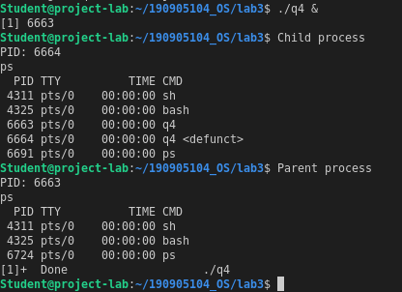

Additional

1) Orphan – Parent dies before child

#include <stdlib.h>
#include <unistd.h>
#include <stdio.h>
#include <sys/types.h>
#include <sys/wait.h>

int main(){
pid_t pid;
int status = 0;

pid = fork();

if(pid == -1){
printf("Error in forking\n");
exit(1);
}
else if(pid == 0){
printf("In the child\n");
printf("Parent PID before parent dies: %d\n", getppid());
sleep(7);
printf("Adopted parent PID: %d\n", getppid());
}
else{
sleep(2);
printf("In the parent\nKilling parent now.\n");
exit(0);
}
return 0;
}

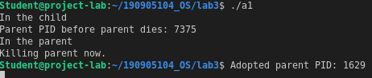

2)

#include <stdlib.h>
#include <unistd.h>
#include <stdio.h>
#include <sys/types.h>
#include <sys/wait.h>

int main(){
pid_t pid;
int status = 0;

pid = fork();

if(pid == -1){
printf("Error in forking\n");
exit(1);
}
else if(pid == 0){
printf("In the child\n");
printf("Parent PID: %d\n", getppid());
sleep(5);
exit(1);
}
else{
// sleep(2);
printf("In the parent\n");
wait(&status);
printf("Child process returned: %d\n", status);
int es = WEXITSTATUS(status);
printf("Exit status code: %d\n", es);
}
return 0;
}
